ID : 2200031128 CH.BHAVANA
1 - Create a Spring Web Project using Maven
TASK :
- Go to https://start.spring.io/
- Change Group as “com.cognizant”
- Change Artifact Id as “spring-learn”
- Select Spring Boot DevTools and Spring Web
- Create and download the project as zip
- Extract the zip in root folder to Eclipse Workspace
- Build the project using ‘mvn clean package -Dhttp.proxyHost=proxy.cognizant.com -Dhttp.proxyPort=6050 -Dhttps.proxyHost=proxy.cognizant.com -Dhttps.proxyPort=6050 -Dhttp.proxyUser=123456’ command in command line
- Import the project in Eclipse "File > Import > Maven > Existing Maven Projects > Click Browse and select extracted folder > Finish"
- Include logs to verify if main() method of SpringLearnApplication.
- Run the SpringLearnApplication class.
SME to walk through the following aspects related to the project created:
- src/main/java - Folder with application code
- src/main/resources - Folder for application configuration
- src/test/java - Folder with code for testing the application
- SpringLearnApplication.java - Walkthrough the main() method.
- Purpose of @SpringBootApplication annotation
- pom.xml
  - Walkthrough all the configuration defined in XML file
  - Open 'Dependency Hierarchy' and show the dependency tree.
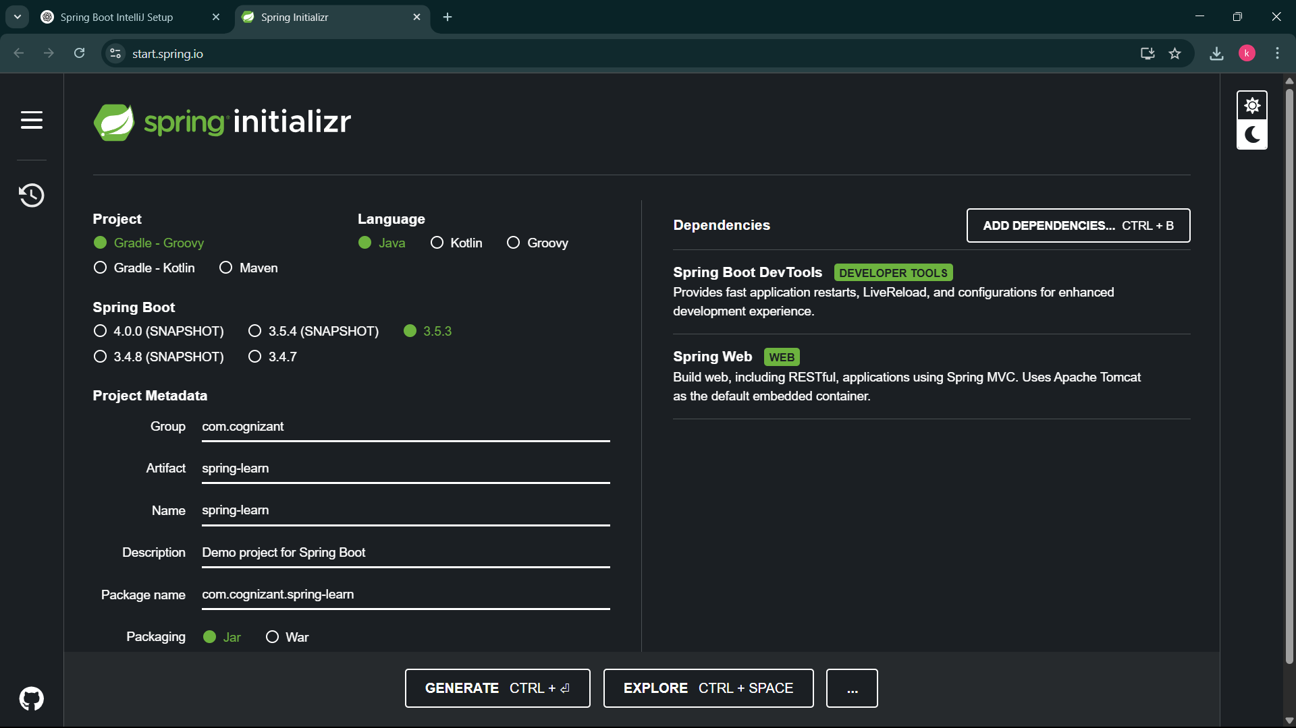
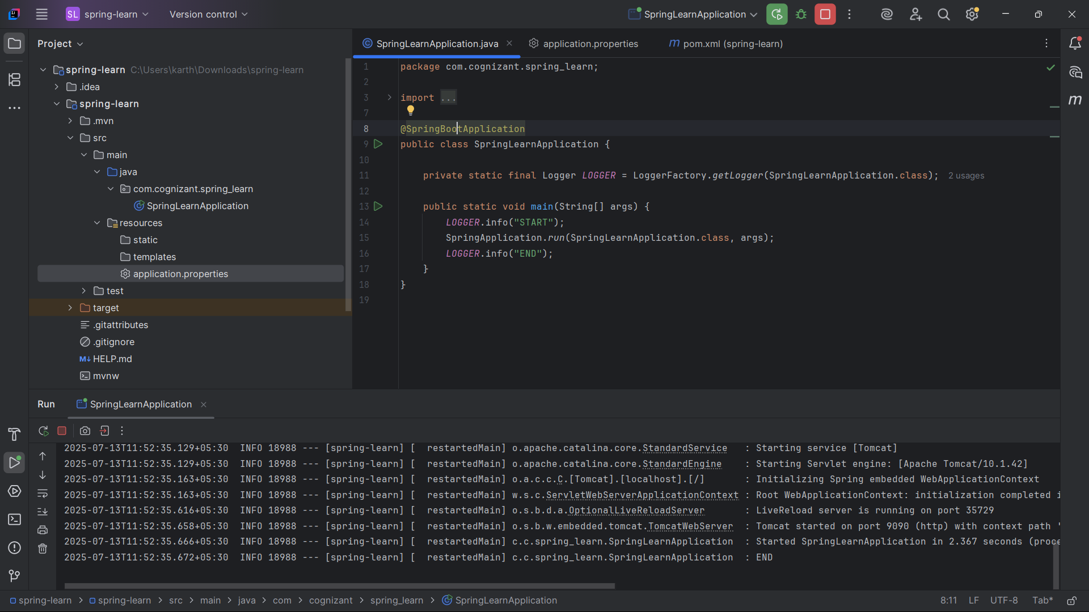
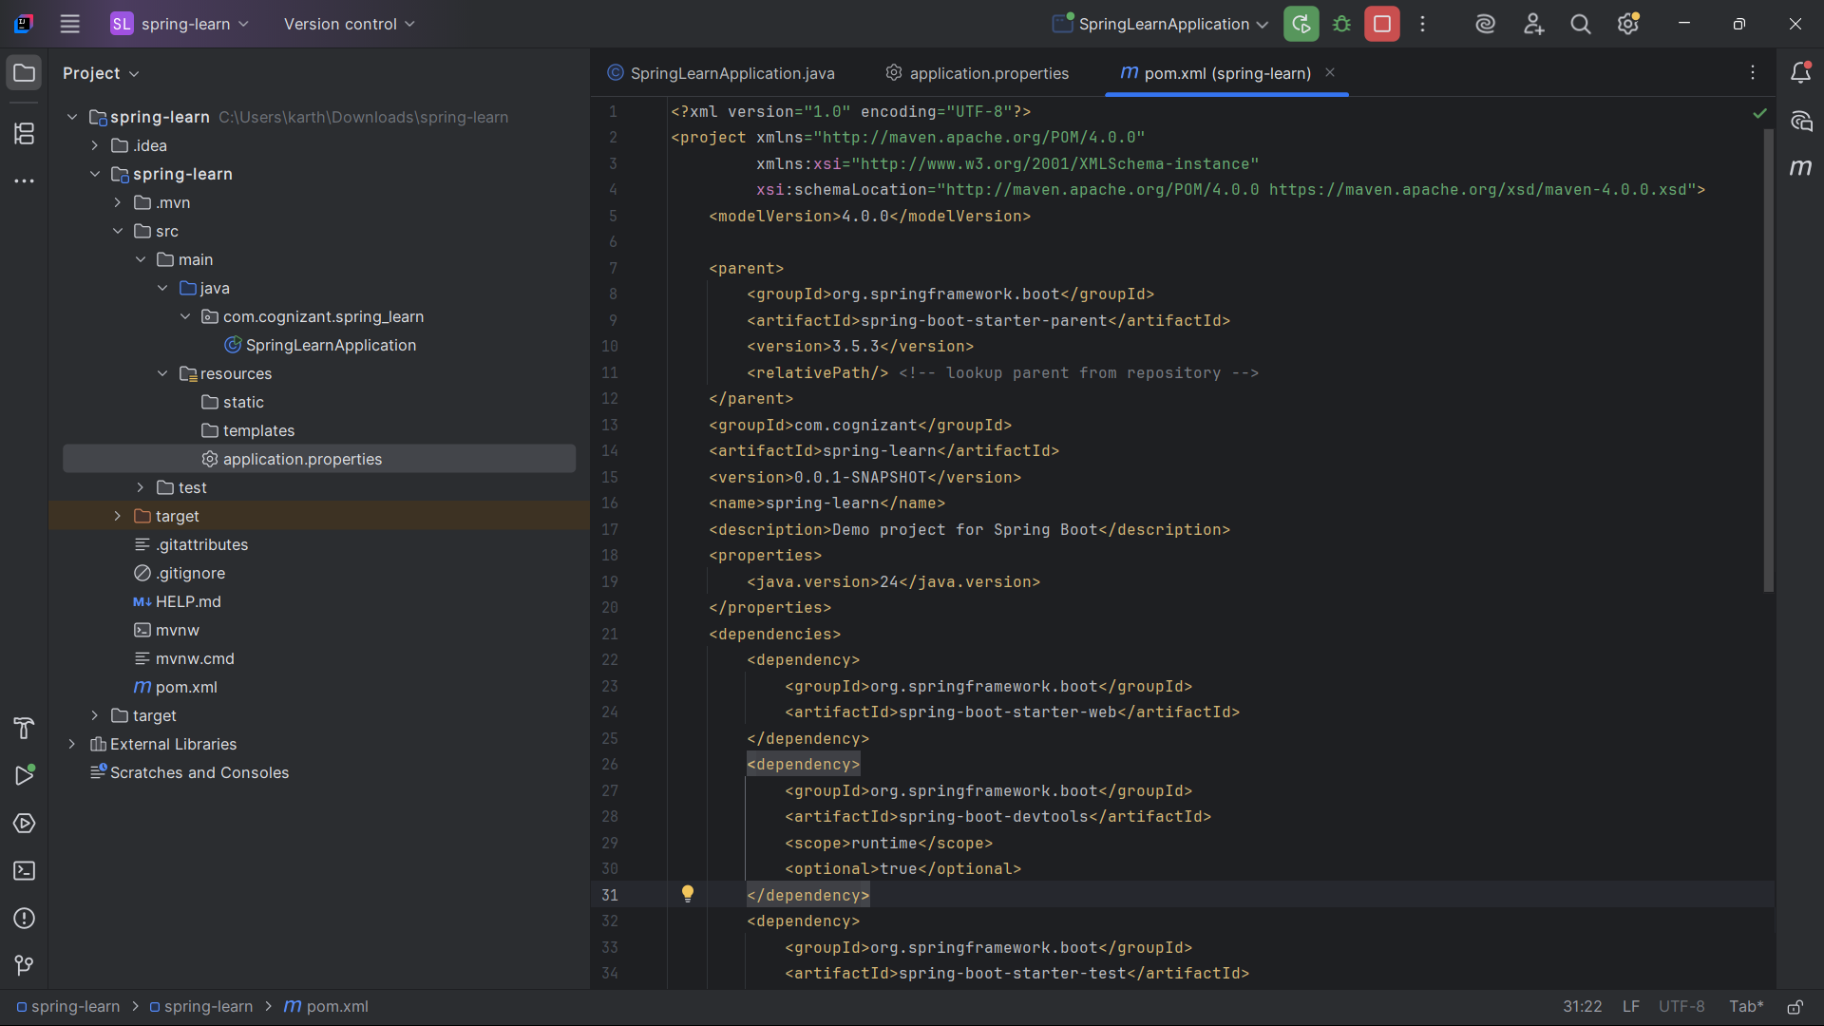

CREATED SPRINGBBOT MAVEN APPLICATION

